**ASSIGNMENT-1**

**Created an EC2 instance**

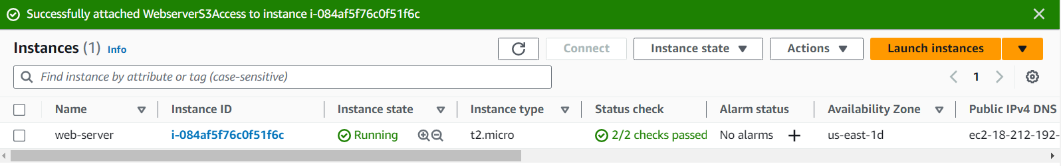

**Created an IAM role for S3ReadOnlyAccess and attached it to the EC2 server**

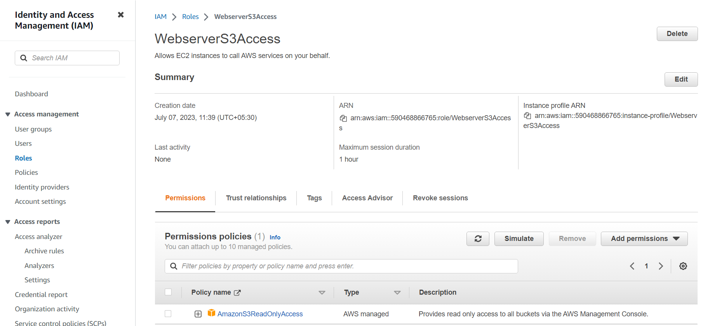

**Created an S3 Bucket**

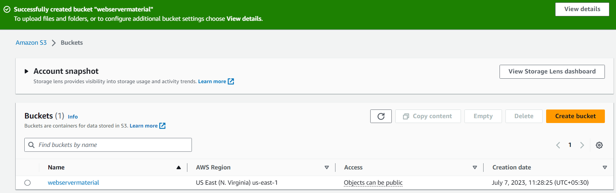

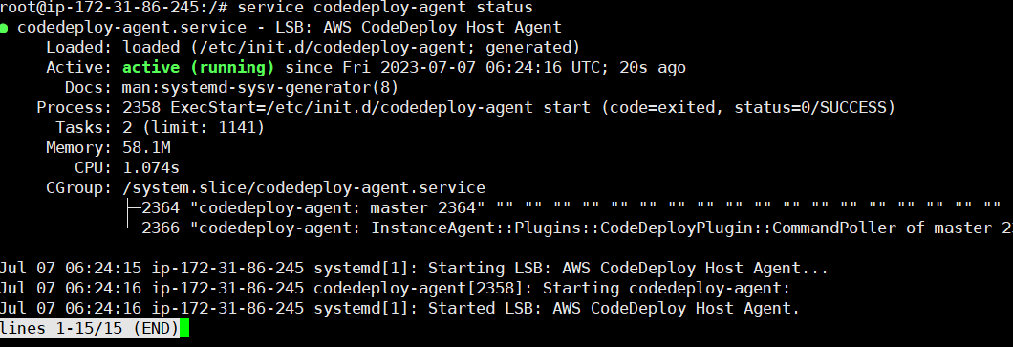

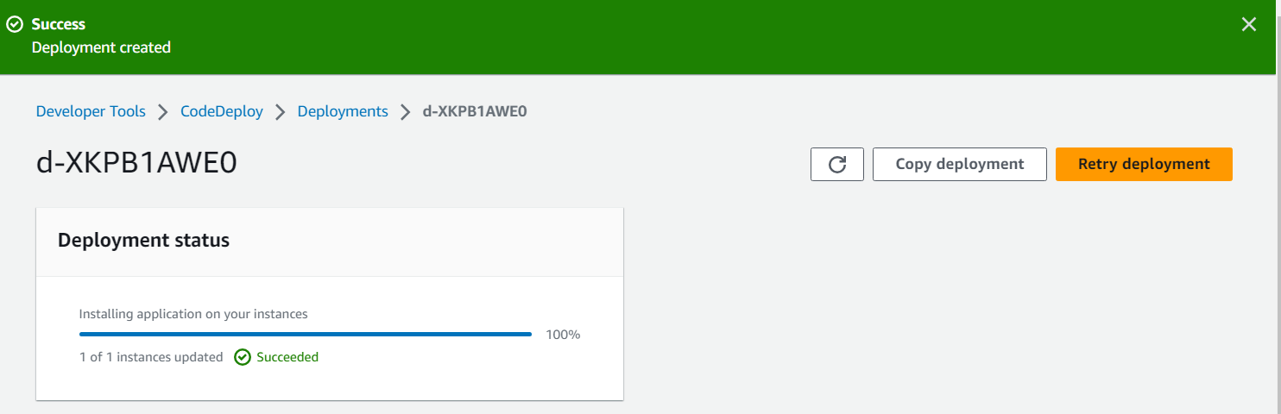

**Output:**

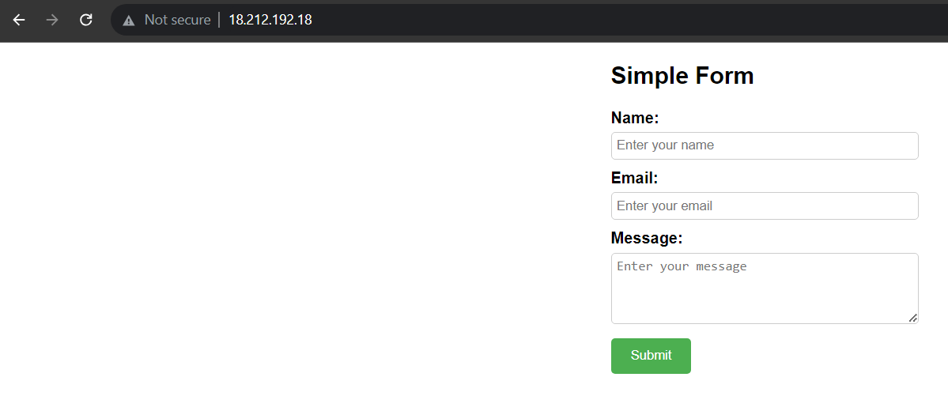

**Update the code in .html file and created a new deployment out of it.**

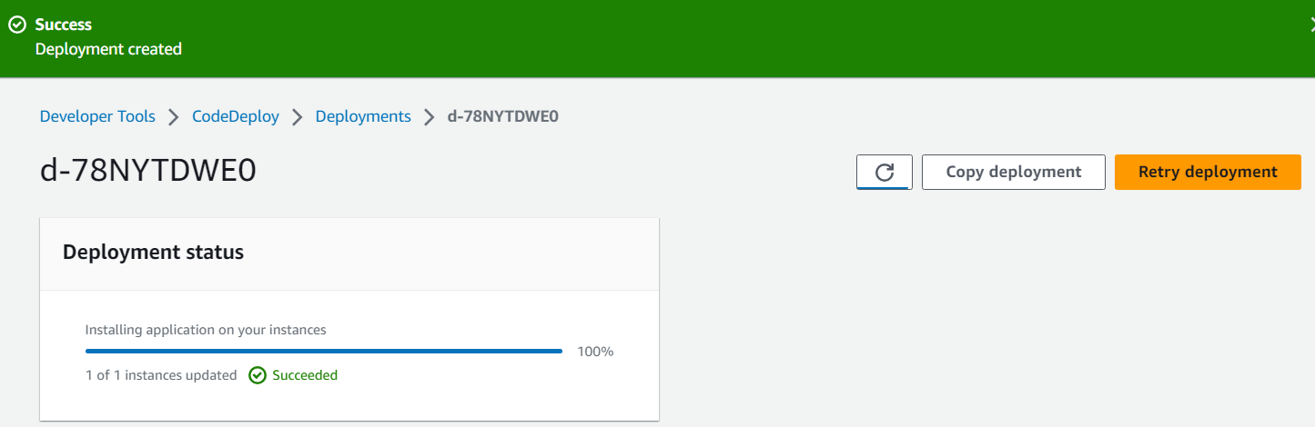

**Updated website:  
